Business proposal Moneymotion
2012
For Fall 2012 (dr Hsieh)
Saving money while working out!
1. Executive summary

1.1 The problem
Gym members take a membership of their gym to exercise and by doing so increase their healthy lifestyle. A large percentage of them has motivation problems to regularly visit the gym. We expect that about 400.000 gym members have motivation problems but pay their gym membership without using the gym at all. This means that motivation problems lead to a waste of roughly €192 mm / year in annual gym membership fees.

This has also implications for gyms, as gyms have 20% of their customers quitting every year. Gyms generally want to prolong their customers‘ memberships as long as possible, but they see that many people stop after a certain period of time (for instance one year) because of motivation problems.

Lack of body exercises has, together with a few other reasons, severe impact on people's lifestyle and state of health. In the Netherlands, an increasing amount of people facing health issues like (chronic) disorders such as: obese, cardiovascular diseases, diabetes, organ failures and epidemics due to the aspects of a healthy lifestyle and increased resistance to disease. Overall, healthcare is getting more expensive year by year, as people get more, better and more expensive healthcare and people have a longer life expectancy. The total healthcare costs is expected to rise from 13% of gross domestic product in 2010 to 23% in 2040 .

In The Netherlands people are obliged to have health insurance in order to pay for their health care. On average, the basic package will cost a customer € 100,- per month per person. Customers often have additional insurance, so monthly costs are usually higher. Health insurance companies have to deal with increasing costs for healthcare and therefore want to keep their customers as healthy as possible to avoid costs and to keep their insurance prices as low as possible (to stay competitive).

1.2 Our solution
We will create an application, called Moneymotion, that will count credits during a workout. By working out, gym goers collect credits and can use them for discounts on their health insurance and other temporary offers. People will collect a credit for every minute they are actively using a fitness machine and for every calorie they burn. Customers have to take an in-test to make sure points are gathered based on the right measurements of the customer. The application will automatically record all the user’s credits through a connection with the fitness instrument. These records are also directly visible on the users mobile phone or tablet.

The credits can be used to get discount on specific advertisements. Every two months multiple companies advertising their deals. These deals can be bought using the saved credits, f.e. buy a theme park ticket with 25% discount after collection of 1000 points. These deals can be bought at home, via Internet or with the app.

Secondly, the number of acquired credits can be spent as a discount on the consumers health insurance. F.e., after one year of sporting, the consumer collects enough credits for 10% discount to have the next year 10% discount on the health insurance. We already see a trend in which health insurance companies support consumers getting a healthy lifestyle (support to stop smoking or discount on gym memberships). We will anticipate on this trend by offering the health insurance the possibility to support actively exercising customers with discount on their health insurance.

As described, customers will save two kinds of credits that can be spend on either advertising or health insurance. With this concept there is a win-win situation for the customer, the owner of the gym, the advertising company and the health insurance company. The customer will benefit from discounts from health insurance and the advertisement which will be an incentive on the short run. By visiting the gym more often, they will (in the long run) also benefit from a better personal health and lower costs for healthcare. The owner of the gym will benefit by getting more customers, by having customers that visit the gym more often and by having less quitting customers. The health insurance will benefit by having more clients with a healthy lifestyle (which is something they already are trying to achieve). This will save them lots of money on healthcare costs. The advertisers can expand their customer range via their advertising.

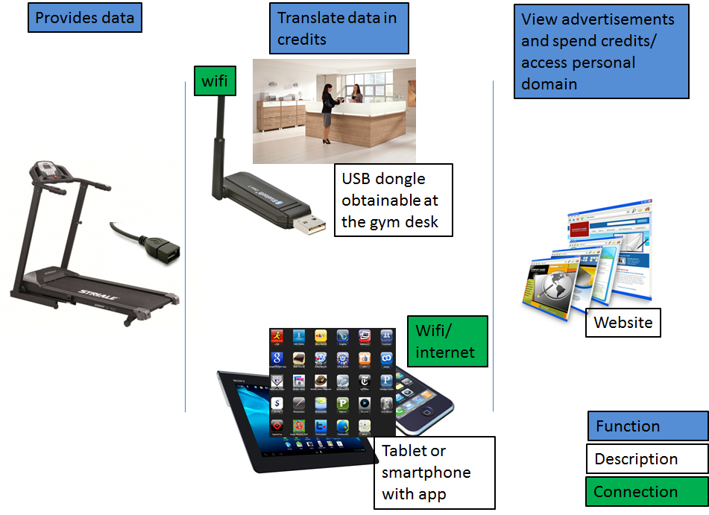
Figure 1: Visualized solution

1.3 Value proposition or business model

As previously proposed in “our solution” we present a business model where all included parties can benefit from Moneymotion. Of course, Moneymotion itself has to make a living. Our business model consist of gaining revenues from three of the four participants: the customer, the gym and the insurance company.

The customer: Pays a one-time fee for subscription to our solution and an additional fee when buying the app.

The gym: Pays a monthly fee per dongle.

The health insurance company: pays Moneymotion a percentage, which is the discount the customer gets for every month health insurance he/she gets. Health insurance companies benefit from healthy customers who don’t claim a lot of (hospital) costs. They will participate in our business because it will ensure them of a less risky customer base. By participating in Moneymotion they receive concrete evidence of how much their customers exercise.

The advertising companies don’t pay any fee for advertisement to start with. In a later stage of our business, we will charge the advertisers a fee. We chose for free advertisement in the initial stage because these advertisements will attract more customers (gym goers). In this stage it is important to get as many customers as possible. Once we have reached a steady customer base, we will charge the advertisers a fee.

1.4 Keys to success
There are a few critical points in the development of our product to ensure success:
1) the insurance companies need to cooperate. It will be a big stimulant for customers of the gym to use our product when they can get a discount on their health insurance.
2) Hardware and software needs to be applicable to the existing sport equipment of all sport schools. Our product will only be bought by gyms if it can be applied to their existing equipment. Obviously, gym owners need to cooperate, buy the tools and provide other items necessary.
3) Companies need to be willing to advertise on this tool. In exchange they can attract new customers.
4) All revenues together should be enough to cover the costs after a certain period. After reaching the break-even point (where the costs and incomes are equal) our company should become profitable. This has to be as soon as possible (and before the initial invested cash runs out).

2. Lines of products or services
The key product of this concept is the software that can be run at the gyms. Next to that there will be an app for the customers. Finally, hardware is needed. A dongle will be developed that customers can borrow at the gym to register their activity without using a smartphone. Our business model is shown in table 1.

2.1 Features

Our application will have a few key functions:
1) The dongle (with the application on smartphone/tablet) uses the data from the fitness equipment to translate it into feedback about performance and credits. The feedback is directly shown on the smartphone/tablet and on the general display at the gym. The dongle, in our solution, is connected through a USB port that is present at many fitness instruments in the Netherlands. Most popular fitness equipment brands like Technogym, Tunturi and Life fitness all have USB connections on the side of the equipment’s display. The data will be further transferred over the Internet to a central database.

2) A personalized domain where consumers can check all their data including the amount of credits they have collected, all active advertisements and health insurance offers. Customers will also see how many credits they still have to earn to apply for the advertisement that is selected as the next goal of the consumer. This personalized domain will also be accessible through an application for smartphone and tablet. This application will be available in the apple/android app store. The application will also have the ability to connect and synchronize with social media.

3) a centralized database that contains all personalized information from the customers. As this is personal information the data will be protected severely. This database can be used by Moneymotion for marketing purposes and to gather statistics for health insurance agencies.

2.2 Price points
As mentioned we offer different packages to the customers.

Consumers
To the consumers we offer an online profile which includes personal data and promotions that are currently active. The registration fee for each (new) customer is €7,95. Once online, the customer can download an app for smartphones or tablets for €0,79. This is a premium account, because with the app the product is more user friendly. As consumers already have monthly memberships for the gym, we would not charge recurring fees.

Gyms
The connection set (that includes installation, software, technical support and the dongles) will be sold to the gyms in the form of a license. The amount of licenses for each gym depends on the amount of fitness machines and consumers they have. There are four packages:
1-15 licenses €8,- per license per month
16-50 licenses €7,50,- per license per month
51-100 licenses €7,- per license per month
101 or more licenses 6,50,- per license per month
Prices convey the lease of the dongle, the use of our software, getting everything installed in the gym and technical support when needed. Depending on the size of the gym, owners can choose a package that suits the gym.
Health insurance
Health insurance companies are likely to benefit a lot from their active customers. We suspect a slight increase in sport related injuries, but also a large decrease in (chronic) disorders such as: obese, cardiovascular diseases, organ failures and epidemics due to the aspects of a healthy lifestyle and increased resistance to disease. This last category of disorders is growing rapidly over time in modern western society, which costs health insurance companies millions per year. Therefore structural reduction is necessary in order to sustain. Moneymotion will only charge the health insurance companies for a small fee per customer, which is exactly the same amount the customer gets as a reduction on his/hers insurance. For instance, if a health insurance company gives 10% discount to a customer, we will also charge 10% to the health insurance company for participating in Moneymotion. For the €100,- per month that is paid, a customer can save €10,-/month with its collected credits. If this customer converts his credits for this discount, we will also get €10,- from the health insurance company.

Advertisers
The advertisers do not have to pay for their advertisement. As advertisements are ‘teasers’ for consumers, we do not want to raise entry barriers for them. The advertiser can place an advertisement every two months, as the advertisement will rotate. The advertising company gains extra revenue by expanding their customer range and are chosen regionally by a first come, first serve principle (but never the same advertisement twice). When the concept turns out to be a great success, multiple companies may be able to advertise at the same time. We can also ask for a fee for advertisements once the system has a large customer base and many companies are interested in advertising.

3. Market and industry analyses
3.1 Target market
Next, advertisers can sell all sorts of products and operate in all sorts of markets. It will be our challenge to find advertisers in different markets but who also sell products in different price ranges to make Moneymotion as attractive as possible for a large amount of consumers.

3.2 Industry analysis

Dutch Fitness and gym market
The Dutch fitness and gym market has grown rapidly since the 1980s. The amount of gyms has grown over the past 30 years together with the amount of people visiting these gyms. In January 2012, 1649 gyms are registered at KvK.
There were 3 start-ups and 41 quitters, which implies that it is a tough business to compete so an innovative approach is needed .
Still, fitness is the most practiced sport in The Netherlands for people older than 18. It rose from 1,4 million participants in 2000 to 2 million in 2005, an increase of 70%. However, after several decades of growth, the growth rate is flattening and the expected growth for 2012 is only 1%.

The participation on gyms is nowadays very high, in many municipalities it is the most practiced sport above sports like soccer and tennis. Gyms are often located in rural areas, run different programs for different customers and have long opening hours. Sporting at a gym can be done individually and together with friends or colleagues. Gyms are therefore the most accessible sports for a large part of the Dutch population and therefore the ‘ target sport’ of health insurance companies to make people sporting.

It is a general trend among gyms that they have issues regarding retention of its customers. It has been described that 20% of the customers will quit its membership of the gym each year. This loss of customers costs the total fitness branch about €180 million each year (on the total turnover of €1 billion).

The gyms are our focus market early in the beginning of commercialisation, as it doesn't make sense to approach the other target markets when there are no gyms participating. There are a few large fitness chains in the Netherlands: Healthcity, David Loyd and Fitness first. These chains offer an all inclusive fitness experience on the high end of the spectrum. There is also one formal Dutch association, with approximately 93 gyms in the Netherlands, which is called the “Nederlandse vereniging voor exclusieve sportcentra”. These gyms also provide a high-quality experience with good equipment and ambiance. The large fitness chains and this association are good focus customer in the early commercialisation as we can through these organisations access a large amount of customers.

Dutch health insurance market
According to the ´Nederlands Zorgverzekerings Autoriteit´ (NZA) there are 10 health insurance companies active in the Netherlands offering 31 different health insurance policies. The four biggest companies have about 85% of the consumers. The market shares of the health insurance companies are rather stable, therefore it makes sense to approach the four market leaders first.
The NZA also mentions that 50% of the the customers pay between € 1.238,- and €1.289 ,- per year for their basic insurance. This means that they pay more than € 100,- per month for their health insurance. The total average costs per customer for health care will be higher, as this will also include costs for additional insurances and costs that are not covered by the insurance at all.

Smartphone and tablet use in the Netherlands
The use of smartphones and tablets is one of the fastest growing trends in the Netherlands. It is mentioned that the Netherlands has the highest integration of smartphones and tablets in the world.
A study from 2012 shows that 44% of the Dutch population has a smartphone and 16% has a tablet. This study also mentions that people use 95% of their time on apps and only 5% of the time on mobile websites. This shows that an app is far more popular on a smartphone or tablet than a mobile website, which indicates that an app is a preferred way of getting access to the personal folder in the software.

Competition
At this moment there is not a product like ours in the market. However there are some products and services that focus on the growing need in personal support to keep motivated during sports.
In the Netherlands the ‘personal trainer’, an app developed by Nike, is quite popular. The app can run on an iPhone or iPod and will give feedback and assistance during running on music selected by the consumer. This program gives some assistance during running and makes it more fun, however there is no real motivation to sport more often or to reward the consumer.

Another company called Ifit offers a product “ifit card weight loss”. This is a product in which a consumer follows a weight loss program of 8 weeks. This program is conducted on a SD card which can be inserted in a fitness machine. This card is not interactive and does not save results. It’s a program that can be displayed on a cardio machine and customers can follow a special weight loss exercise program. There is no app connected to this product.

Furthermore, Technogym has developed the Wellness-Key. This key saves data to a central computer at the gym with a wireless connection. It allows customers to be guided during training and takes care of the right settings of the equipment. This product doesn’t combine the advertising and the benefit for health insurance.

3.3 Concluding statement

Build on some assumptions, we made a calculation about the profitability of this company (see table 1 on the next page). We estimate to have the company up and running and all functions ready within 16 months. We have estimated that we need a total one-time investment of €440.000,-. Next to that we expect €28.000,- on monthly recurring costs. This would mean that we need about €944.000,- before going ‘live’. These investment costs are described more in detail in chapter 6. Once we are fully up and running, we expect increasing revenues. A first estimation is that we need about 2000 active users to cover our monthly recurring costs. Once we have more active users, we will be able to redeem on the investment. We expect this will happen within a few months after going ´live´. At this moment we haven't calculated the time frame after which we paid back all initial investments and start making profit.

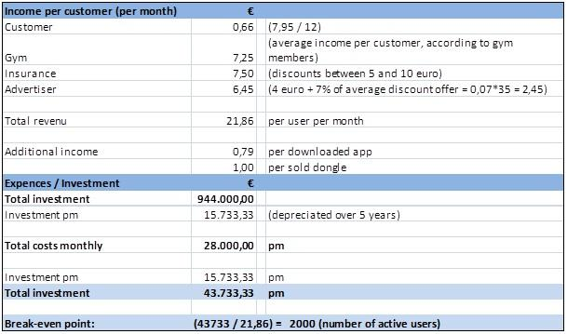
Table 1: expected earnings

4. Our strategy
In order to get revenues up and running, it is crucial to attract all parties into the system. At the start of Moneymotion the number of health insurance companies, gyms, advertisers and customers will be small. When the concept proves to be successful, the numbers of all the involved parties is likely to grow. Where the involvement of gyms and health insurance companies is mandatory before the launch of the product, customers and advertisers will be more likely to join after the launch (due to a viral process).
We shall therefore have to attract some of the Dutch health insurance companies before the launch of the product. In order to do so, we will plan meetings with a selection of the companies. This selection is made by estimating the willingness of the company through initial e-mail and telephone contact.
Gyms will be attracted and selected based upon their size. We expect that large gyms are more eager to engage with us and they represent a larger customer group. The customers of these initial gyms will receive our service for free at the beginning in order to ensure a “startup group” of all four parties at the launch of the product, we may have to select a pilot group of gyms and customers which can try the product for free. Once a demand increase for our product occurs, we can start to charge new customers and gyms for their participation. An increase in customers and participating gyms will most likely also lead to the participation of more health insurance companies (and advertisers).When the demand for our product increases and the product itself becomes known to the public, our pricing towards all parties can (and should be) reviewed. Advertisers for instance, can be charged a fee per sale they make through our medium after the target market becomes really interesting to them (this fee is also shown in table 1).

4.1 Product or service design considerations
We described the key features of Moneymotion.in paragraph 2.1. The tangible features specifically are the dongle and the application for tablet and smartphone. For sake of argument, the website is also a tangible feature.
The dongle or the application on smartphone/tablet uses the data from the fitness equipment to translate it into feedback about performance and credits. The feedback is directly shown on the smartphone/tablet and on the general display at the gym. The dongle, in our solution, is connected through an USB port that is present at many fitness instruments in the Netherlands. The data will be further transferred over the Internet to a central database.
We charge a fee to the customers for the app and to register to the website. We charge the gyms a fee per license per month to use the dongle. Price points were determined by making comparisons on the internet. The price for the app is reasonably standard and prices for the licenses for the dongle were reasonably determined by the founders of Moneymotion.

4.2 Partner/supplier/vendor agreements

To make Moneymotion a success, some partnerships are essential. Firstly, we have to partner with the health insurance companies. These partnerships will be formal. It is not a key success factor that we partner with all existing health insurance companies, but there should be partnerships with at least two big companies and preferably also a small company to begin with in order to spread the chance of appealing to customers with these particular insurances. Customers can only transfer to a new health insurance company by the first of January each year, so it would be beneficial to partner with as many health insurance companies as possible.
Secondly, we have to partner with the gyms. The more gyms will participate in our project, the better. They will buy a certain number of licenses which will be recorded in a formal agreement.
Lastly, we have to build partnership with advertisers. In the startup phase of Moneymotion, these partnerships will be informal. Advertisers do not have to pay a fee to advertise. We chose this kind of partnership because it has to be attractive for advertisers to participate in a startup project. Once multiple gyms and customers participate, the partnerships with advertisers will be formalised and we will charge a fee per sale which is conducted through our Moneymotion platform.

4.3 Marketing and sales strategy

Our marketing and sales strategy begins with getting the gyms and health insurance companies to participate. We will start with making appointments with the health insurance companies. We contacted several companies and three them were interested in making an appointment to talk about the details (Achmea, FBTO and Zilveren Kruis).
Next, we will use the participation of health insurance companies to get the gyms on board. Firstly we focus on gyms in large cities because with new products and services large cities are a step ahead of smaller cities and towns, they form an example. Furthermore larger gyms are expected there, so more licenses can be sold and a license is less risky to them.
We think the advertisers are most likely to go on board because they have no financial risks, therefore they are approached last. A focus is placed on advertisements of supplementary goods because then it is even more interesting for advertisers to join. Goods like running shoes, sports clothes, water bottles and heart rate monitors are goods that supplement our service.
Of course our potential customers are to be approached as well in order to make the concept interesting to all parties. When the insurance companies and gyms have taken an interest in our product, we shall commence with gaining customers.

4.4 Distribution strategy

Customers
When gym goers buy the app and open a personal account on the website, they can instantly see how much discount they have collected. They receive the personal account and app after-sale, and the collect their reward “after-workout”.

Gyms
Gyms will receive their products (dongle, software) after sale.

Health insurance companies
We will make pre-sale agreements with health insurance companies about the discounts customers will receive, and the fee Moneymotion will collect. Payment towards the customers and to our company will take place “after-sale” (meaning, after the customer has completed a month of training and the reduction on his/hers health insurance bill is defined). We can make arrangements with the health insurance companies whether or not they will pay the customer themselves, or that Moneymotion will take care of the financial compensation towards customers.
Advertisers
Advertisers do not pay a monthly fee in order to advertise, but they will chip in after our customer group gets big enough. We will then charge an after-sales fee for every transaction our advertisers conduct.

4.5 Service strategy

We will offer technical support to the gyms after they have bought the licenses. This support will cover the dongle and software. However, it is our goal to conduct software and hardware which is very approachable (plug and play) so this aspect can be minimized.

In the initial phase our management team will be the technical support. We will make the connection with the company that made the software and provide customer service ourselves.
There will also be support for gym customers. The website will contain a FAQ section. Other questions can be asked at the gym. If they can’t answer them, the gym can contact Moneymotion and we will provide customer service. After we are break even, we can outsource the customer service and helpdesk.

4.6 Source of competitive edge

To maintain a competitive advantage Moneymotion has to focus on current and future trends. One of the current trends is that companies focus on a sustainable way of doing business. To make Moneymotion more social sustainable, we may have to focus on socially beneficial projects. A way to achieve this is to include social advertisements. This means that the credits customers collected are not “cashed out” but are used to sponsor social activities. This means that both customers and advertisers work together to achieve this goal.

Furthermore Moneymotion can become more environmentally sustainable. A way to achieve this is to use only green energy for the websites and servers. It can also sponsor environmental projects, the same way as described above. Furthermore it can stimulate gym owners to use the generated energy for powering the equipment.

Finally to stay competitive, Moneymotion has to keep on innovating on its service to stay ahead of competitors. In paragraph eight is described how Moneymotion can expand and keep ahead of competitors.
5. Organizational summary

The company will be first divided into three divisions; Marketing&Sales; Technical support and R&D; and Finance&accounting. This separation is based on the team members background and previous experience. Jelle Arts will be the CEO, Schelto Korf will be head of marketing&sales, Freek Gieles will be head of technical support and R&D and Ewa petiet will be head of Finance & accounting.

5.1 Organizational structure

Schelto Korf is the perfect candidate to be head of marketing & sales as he has a over seven years of sales experience and a proven track record at three comparable positions in different industries. Freek Gieles is best suitable for the function of head of technical support and R&D. He has a technical background and has worked as an engineer in the army for four years. In this function he has built up a lot of experience about different fields including information, mechanical and construction technology. Jelle Arts has the most experience with leadership and general management. Also, he has the best skills to look at our company with a general perspective and to make decisions on outlines because of his previous work experience. This is why we chose Jelle as the CEO. Ewa Petiet will be head of finance & accounting. She currently works as HR-advisor with a strong link to the finance department. Of all four owners, she has the most experience and best feeling with finance and accounting.

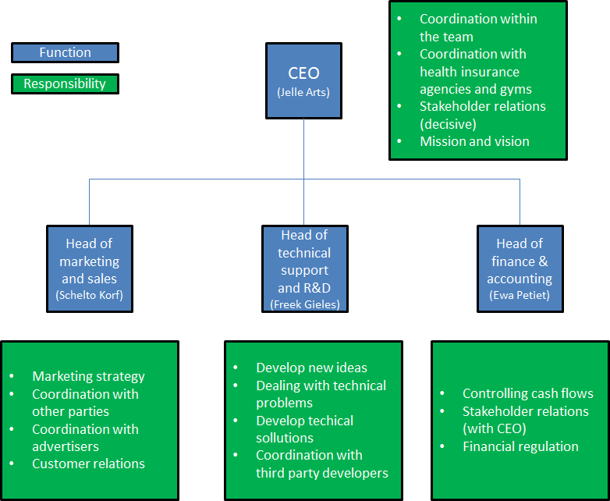
Figure 2: function vs responsibility

5.2 Compensation scheme

First of all Moneymotion will use its profits to pay back investors so debt is lowered. When all debts are paid the company will use the money to invest in expansion and marketing to grow larger. Furthermore, 5% of the profits will be divided among the founders when the balance sheet turns positive, and the rest will be reinvested to further enhance the company. This way good work will have its payoff directly. When investors stay shareholders, a dividend may be a solution for rewarding them for the investment they made and risk they took. The four founders will each earn the same salary of €4500,- per month.

5.3 Coordination and Decision-making Rules & Policies

In the initial phase, until we will start making a reasonable profit, decisions will be made through democratic votes when they affect multiple areas of expertise. When the company starts to grow the CEO will make the “decisions” by developing the mission of the company. The other officers will be responsible for their own fields and advise the CEO when decisions have to be made which impact the entire company. In order for all officers to keep track of the general progress which is being made in the different areas of expertise, a daily stand-up meeting is held at the beginning of each day. This will further strengthen the cohesion between the officers and will ensure that all players stay on course. When the company grows even further, a board of directors will be assembled. As the investors will never own more than 49% of the shares the company can take most decisions relatively independent of their investors.

5.4 Statement regarding company ownership

First 20% of the ownership goes to investors, when the second part of the investment is needed 40 % of the company ownership goes to the investors. The rest of the company will be divided equality among the four founders of Moneymotion. Especially in the beginning tasks will be divided among the team members but probably consensus is needed to take important decisions. When the company starts to grow and tasks will be more delineated, a decision has to be made which tasks are more time consuming and require more experience and more skills. Based on this decision ownership or salary may change. Also when other employees or investors want shares of the company everyone can decide if they want to sell (parts of) their shares.

6. Financial Plan

Expected earnings and costs are displayed in table 2.
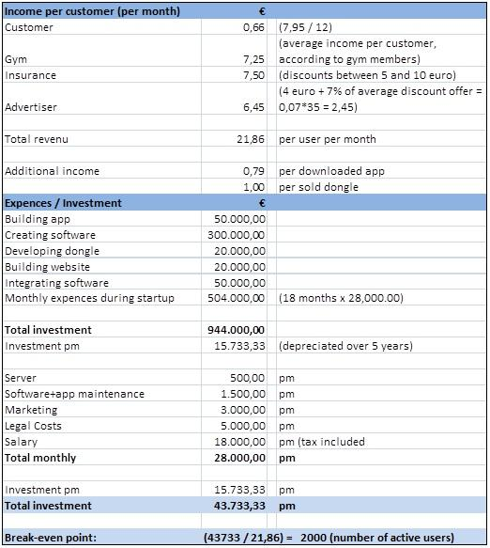
Table 2: expected incoming and outgoing cash flows

6.1 Start-up funding

All of the amounts mentioned in this paragraph can be explained further when analysing Appendix 1. Prior to the launch of the product, our company will need €440.000,- in order to develop and produce the necessary software and hardware which is mandatory. We estimate that this process will take up to 18 months. During this period we will also have overhead costs which come down to approximately €28.000,- a month. This means that prior to the launch of our product, we will have to invest a total amount of €944.000 ,-
When the product goes live, we expect to start with 500 active customers in our pilot group. It is to be expected that this group will expand 10-15% each month. Since the initial pilot group of customers and gyms are not charged with our service (they have the sole purpose of being a marketing tool), we will not receive full revenue from this group (only 13,95 per customer). The customers (and gyms) which join next will bring in full revenues (which are 23,86 per customer).

Given the investment costs and the monthly costs, compared to the earned revenue (in line with the growth of our customer group) we need approximately one year after our product goes live before our monthly income exceeds our expenses. At this moment we are profitable. It will take us three and a half year to completely earn back our investment and have a positive balance sheet.

We would need a total investment of €1.067.000,- for product development and covering all costs we will have until the company is break even. We divided our expenses in two categories:
1) Expenses for product development. These expenses covers all costs that are directly related to the development of all hardware and software tools. These costs are estimated at €440.000,-
2) Recurring supporting expenses. Most of these expenses are recurring and the monthly costs are and the average monthly costs are estimated at €28.000,-

The product will be launched 18 months after startup and will be break even after 32 months.

We will need a start-up VC investment of €632.000,- to finance first 12 months. This is based on 12 months with average monthly recurring costs of €28.000,- (about €336.000,- in total) and a large part of the product development costs (we estimate about €296.000,- of the €440.000,- needed for product development). At the end of the first year we will need a second investment of €435.000,- which is enough to reach the breakeven point of the company.

6.2 Break-even analysis

The application will be launched 18 months after the company startup. We will need a total investment of €1.067.000,- to get at the point that it will be break even (after 32 months). From this point our income will exceed our expenses.
In the first year after launch we expect to generate revenues from the gyms (monthly recurring revenues), revenues from subscription and apps sales (one time revenues from new customers) and monthly recurring revenues coming from health insurance companies. As 44% of the Dutch inhabitants has a smartphone, we expect that 40% of these new customers will also buy the app for €0,79. These three revenue streams together will be enough to cover our monthly expenses after 32 months.

6.3 Projected Cash Flow

The cash flow can be divided in two different cash streams which are the incoming and the outgoing cash.
We have split the outgoing cash in two categories which are 1) investments costs for product development and 2) average total monthly costs (which consists of recurring costs). The expenses of these two categories are further split up in our financial plan (table 2).
The incoming cash flow consists of three incoming revenue streams (from consumers, gyms and health insurance companies). These three revenue streams change over time. Directly after the we we will start getting (monthly recurring) revenues from the gyms and (one time) revenues from the customers (subscription fees and downloads of the app). We expect that the health insurance companies are only willing to discount customers that have proven to work out regularly over time, therefore we expect that they will generate revenues about one year after the launch of the product. These three revenue streams are visualised in figure 3 below.
In a second stage of commercialisation we might charge the advertisers once we have reached a certain volume of gyms and customers participating.

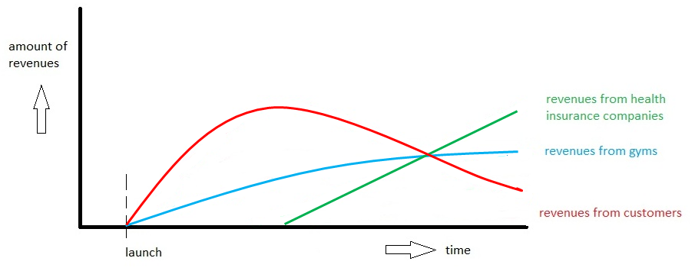
Figure 3: The development of flows of revenues over time.

The negative and positive cash flows together result in the net monthly cash flow as shown in the figure below (Figure 4). In the first year we will highly invest in product development, which explains the initial negative cash flow. After 12 months the cash flow used for this investments declines as most of the investments for product development are done.
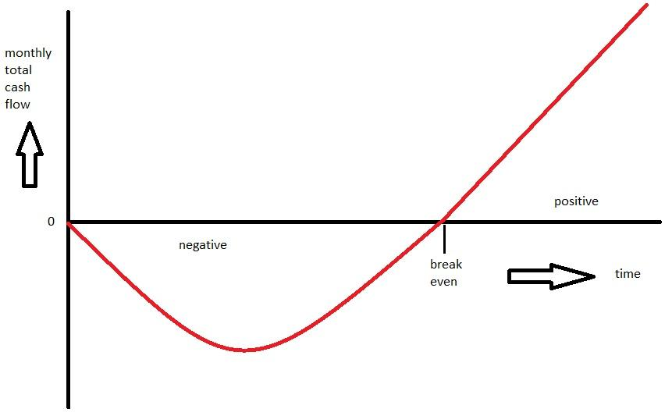
Figure 4: The expected net monthly cash flow over the first three years

6.4 MBV Spreadsheet

The MBV spreadsheet is not easily applicable to our business model. We don’t sell one product to one target market. We decided to break up the MBV spreadsheet and only use the modules we can use for Moneymotion.
Our monthly burn rate will be € 28.000,-. The largest part of these costs are the salaries of the founders, namely €4500,- each. Next to that we will spend €3000,- on marketing & sales and €2000,- on IT and legal costs. Finally, we will save €5000,- each month for legal costs.
When we look at our costs, we won’t have costs for royalties or patents. Furthermore, labor costs are limited to the initial phase. When the software needs to be developed, costs will rise to €28.000,- per month. That is why an investor will invest in Moneymotion in exchange of shares and cover these costs. After that, labor costs will decrease. There are no costs for other personnel and costs for materials will be €2.000,-.
If we want to calculate prices, we need to look at specific target groups. For instance, gym goers pay a different fee than gyms. We believe that it is most interesting to look at costs for gyms. Specifically, the licenses they pay per month. As we mentioned earlier in this business plan, we approximately need 2000 active users to break even. This is calculated including all target groups - gyms, gym users, advertisers and health insurance companies. If we only look at licenses from gyms, the MPV spreadsheet shows that an increase of costs will lead to a later breakeven point. Also, when we raise prices of the licenses, breakeven point will be earlier and our gross profit per unit will increase.

7. Contingency plan

There are some external environment changes that may arise in the future that might prevent Moneymotion from making a profit. The first would be an institutional change. When a social oriented political party (with more left-wing ideas) gains more influence in the Netherlands there is a bigger chance differentiation in healthcare premiums is forbidden. This would mean that Moneymotion is not able to cooperate with health insurance companies anymore. The whole incentive for customers to sport on a regular basis is then gone. The only thing Moneymotion can do about this is to make the service as accessible as it can, so that the largest part of people see the benefits instead of the disadvantages.

Another environmental change which may occur, is the entry of new competition into the market. At this moment Moneymotion has a first mover advantage (there is no similar service in the Netherlands at this moment). When others get wind of the concept, or the success Moneymotion has, it is likely copycats will emerge. In order to prevent this from happening we can patent technology and make exclusive contracts with health insurance companies. The last option is not very likely during the startup of the company, but it is something which should be obtained. However, as it is known in all business segments, effective and profitable technology and business concepts are always of temporary nature. Moneymotion has to focus on maintaining a competitive advantage by constantly improving and reviewing its concept, methods and processes. This can be achieved through conscious analysis of the environment in which we operate. This should be part of the routine within the management. It’s the CEOs task to monitor and engage towards the outside world and to involve the other officers while doing so.

8. Expansion plan

There are a few steps Moneymotion can take to expand the current business model.
The first is geographical expansion. We expect that this business model can be successfully converted to other countries. Germany, the United Kingdom and the United States seem the most logical choices for geographical expansion for a few reasons. These reasons are language, amount of inhabitants and the integration of (mobile) internet in society. We should further investigate whether there are possibilities to collaborate with health insurance companies in these countries and how Moneymotion can be successful in this situation. We can also consider to sell or license this concept to local parties in these countries, as they have a better knowledge of the local market.

Another way to expand, is to develop an application for a smartphone or another device that can be used to measure physical performance in general. For example by measuring speed, distance, steps, heart rate and temperature other sports can be integrated in the Moneymotion concept. The gym-owners are then left out the equation, but the concept will still be interesting for health insurance companies and advertisers.

An interesting but maybe controversial idea is to include life insurance companies in the concept. Not only the health of customers improves by sporting on a regular basis, also the life expectancy is improving. When life insurance companies are onboard, we can develop other devices that further enhance the health or life expectancy can be developed. For example developing devices that measure car speed, driven kilometers a year, seatbelt wearing, smoking and using soft drugs.

9. Bibliography

Freek Gieles
Personal profile

Excellent team player ,enthusiastic, effective verbal and written communicator with proven analytical skills, energetic and competitive achiever, manage multiple priorities, strong manage, interpersonal skills, positive, motivated, creative, flexible, curious, independent, dynamic.

Work Experience

February 2011 to present: Platoon Commander
412th Armoured Engineer company, Army, Ministry of Defence, Oirschot.

February 2009 to February 2011: Platoon Commander
101st CBRN-defence company, Army, Ministry of Defence, Wezep.
Platoon Leadership in combat and peace operations. Duties were similar to the ones described above.

Education

2011-2013: Business Studies Intensive Programme (MSc)
University of Amsterdam (Amsterdam Business School)

2004-2008 Bachelor of Science in Civil Engineering
Twente university, Enschede, Netherlands.
Bsc Thesis: Optimisation of the groundwork of military compounds.

Jelle Arts

Personal profile
Leader - Team player - Logistic professional - Open minded - Goal oriented - Caring
My personal goals are: To keep on learning , To improve my (and learn new) skills, To be happy in life
My professional goals are: To keep on developing as a logistics expert, To always being able to make a difference

Work Experience

06/2012 – present Chief of logistics - Royal Netherlands Air Force
The Chief of Logistics is responsible for the internal logistic process at Airbase Woensdrecht and manages the logistic department, which consists of several units. All of these provide their service at the Airbase: Logistic Support Elements, Distribution Centre, Warehouse, Management Information Bureau, Publication Management Section, Petrol Oil and Lubricants Department (47 FTE).

01/2011 – 06/2012 Team leader SAP implementation - Defence Materiel Organisation
Guiding the Logistic Centre Woensdrecht (LCW) during the implementation of the new ERP system SAP. Daily tasks are to convert & structure the current logistic business processes, so SAP implementation will go more smoothly.

06/2009 – 01/2011 Supply Chain Analyst - Defence Materiel Organisation
Managing the supply chain of the Cougar helicopter is a diverse process. The daily efforts in my job consist of: analyzing customer behavior, optimizing stock values, looking into warehousing strategies, networking with suppliers, annual forecast, etc.

Education
2011-2013: Business Studies Intensive Programme (MSc)
Expected graduation August 2013
2005-2009: Military Business studies (BSc)
Graduated successfully

Schelto Korf

Personal profile
Enthusiastic, independent, result driven, commercial and strategic thinker, team player.

Work experience
2011-1012 Senior Key account manager at BaseClear B.V.
Responsible for marketing and sales for Next Generation Sequencing and Molecular Biology Services.
2009-2011 Key account manager at Dako Benelux B.V.
Responsible for sales of reagents and automation for immunohistochemistry, histology and molecular testing for pathology Laboratories in the Netherlands.
2005-2009 Key account manager life science at QIAGEN Benelux B.V.
Responsible for sales o f products for reagents and automation for academical, forensic, biotech and pharmaceutical accounts in Half of the Netherlands
2001-2004 Salesman at bicycle store Profile-Pro de Fietsspecialist, Wageningen

Education
2011-2013 University van Amsterdam, Amsterdam Business School, Business Economics, MSc
specialisations: marketing and strategy
1998-2005 Wageningen University, Molecular Science, Bsc and Msc
specialisations: molecular biology and biotechnology

Ewa Petiet

Personal profile
My interest lays in the field of HR. I'm good at motivating people and encourage action. Work in a team suits me and I like to find creative solutions to challenges that I encounter.

Education
2011-2012: Master Business studies Amsterdam Business School
2006-2007: Master Organisatiepsychologie Universiteit Utrecht
2003-2006: Bachelor Work psychology Vrije Universiteit Amsterdam

Work experience
2012-present HR advisor at Gemeente Stichtse Vecht
responsible for advising management on all HR topics, formation and budgeting on labor costs, absenteeism guidance, guidance on heavy HR files.

2010-2012 HR advisor at Gemeente De Ronde Venen
responsible for recruitment, advising management on HR topics, organizing labor markets, absenteeism guidance, career guidance, training for 10 to 300 people.

2009-2010 HR employee at Gemeente De Ronde Venen
Responsible for labor markets, recruitment / marketing projects, providing training advice and policy making, establish a career and mobility center.

2007-2009 Traineeship organisation development at Gemeente De Ronde Venen
Responsible for the development of the organization and the staff.

10. Appendices
Appendix 1: Balance sheet / Break-even Analysis

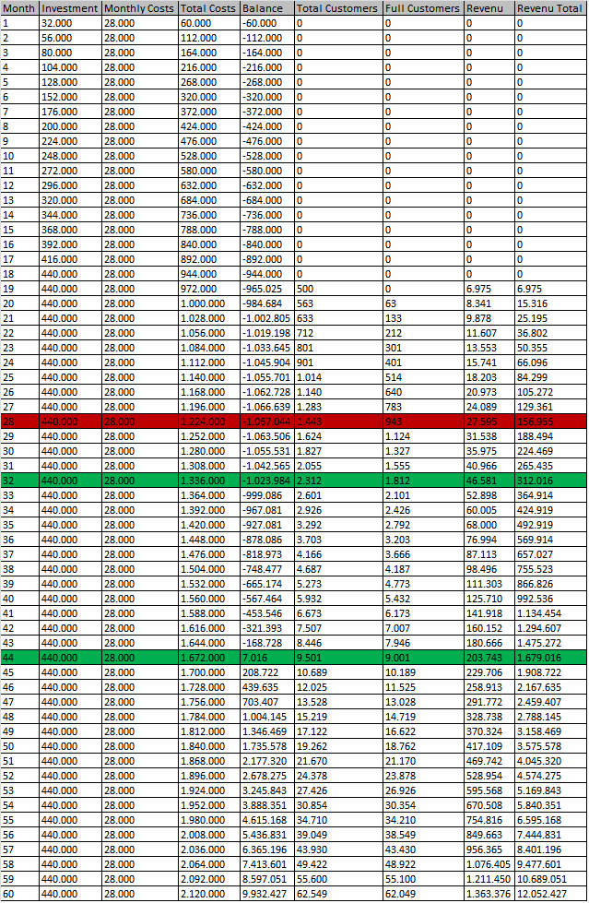

Van der Horst, Van Erp & De Jong, Trends in gezondheid en zorg, CPB policy brief, 2011/11
www.kvk.nl/ondernemen/brancheinformatie/branchewijzer/persoonlijke_diensten/fitness/fitness/ viewed on 2-10-2012
http://www.kvk.nl/ondernemen/brancheinformatie/branchewijzer/persoonlijke_diensten/fitness/fitness/viewed on 19-11-2012
http://www.mulierinstituut.nl/projecten/monitoringprojecten/fitnessmonitor.html viewed on 19-11-2012
http://www.nza.nl/104107/105773/354532/Marktscan_Zorgverzekeringsmarkt.pd f viewed on 2-10-2012
http://www.elsevier.nl/web/Nieuws/Internet-Gadgets/350085/Nederland-koploper-met-smartphone-en-tabletgebruik.htm viewed on 2-10-2012

